How to View IEPs in PowerTeacher- 2024-2025

Log in to powerteacher from the district website- like you would normally take attendance. | 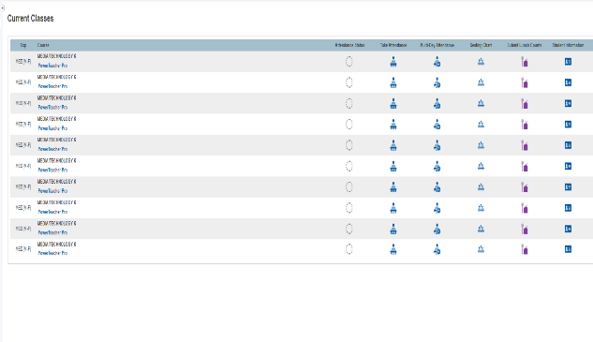
Click on the student information tab next to the homeroom section of your class. | 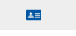
Scroll down and click on documents | 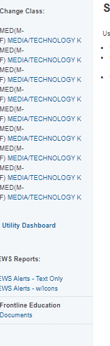
It will say processing when it is loading.  The list of students that have an iep will come up.  Click on the icon below IEP to open the IEP.  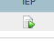 | 